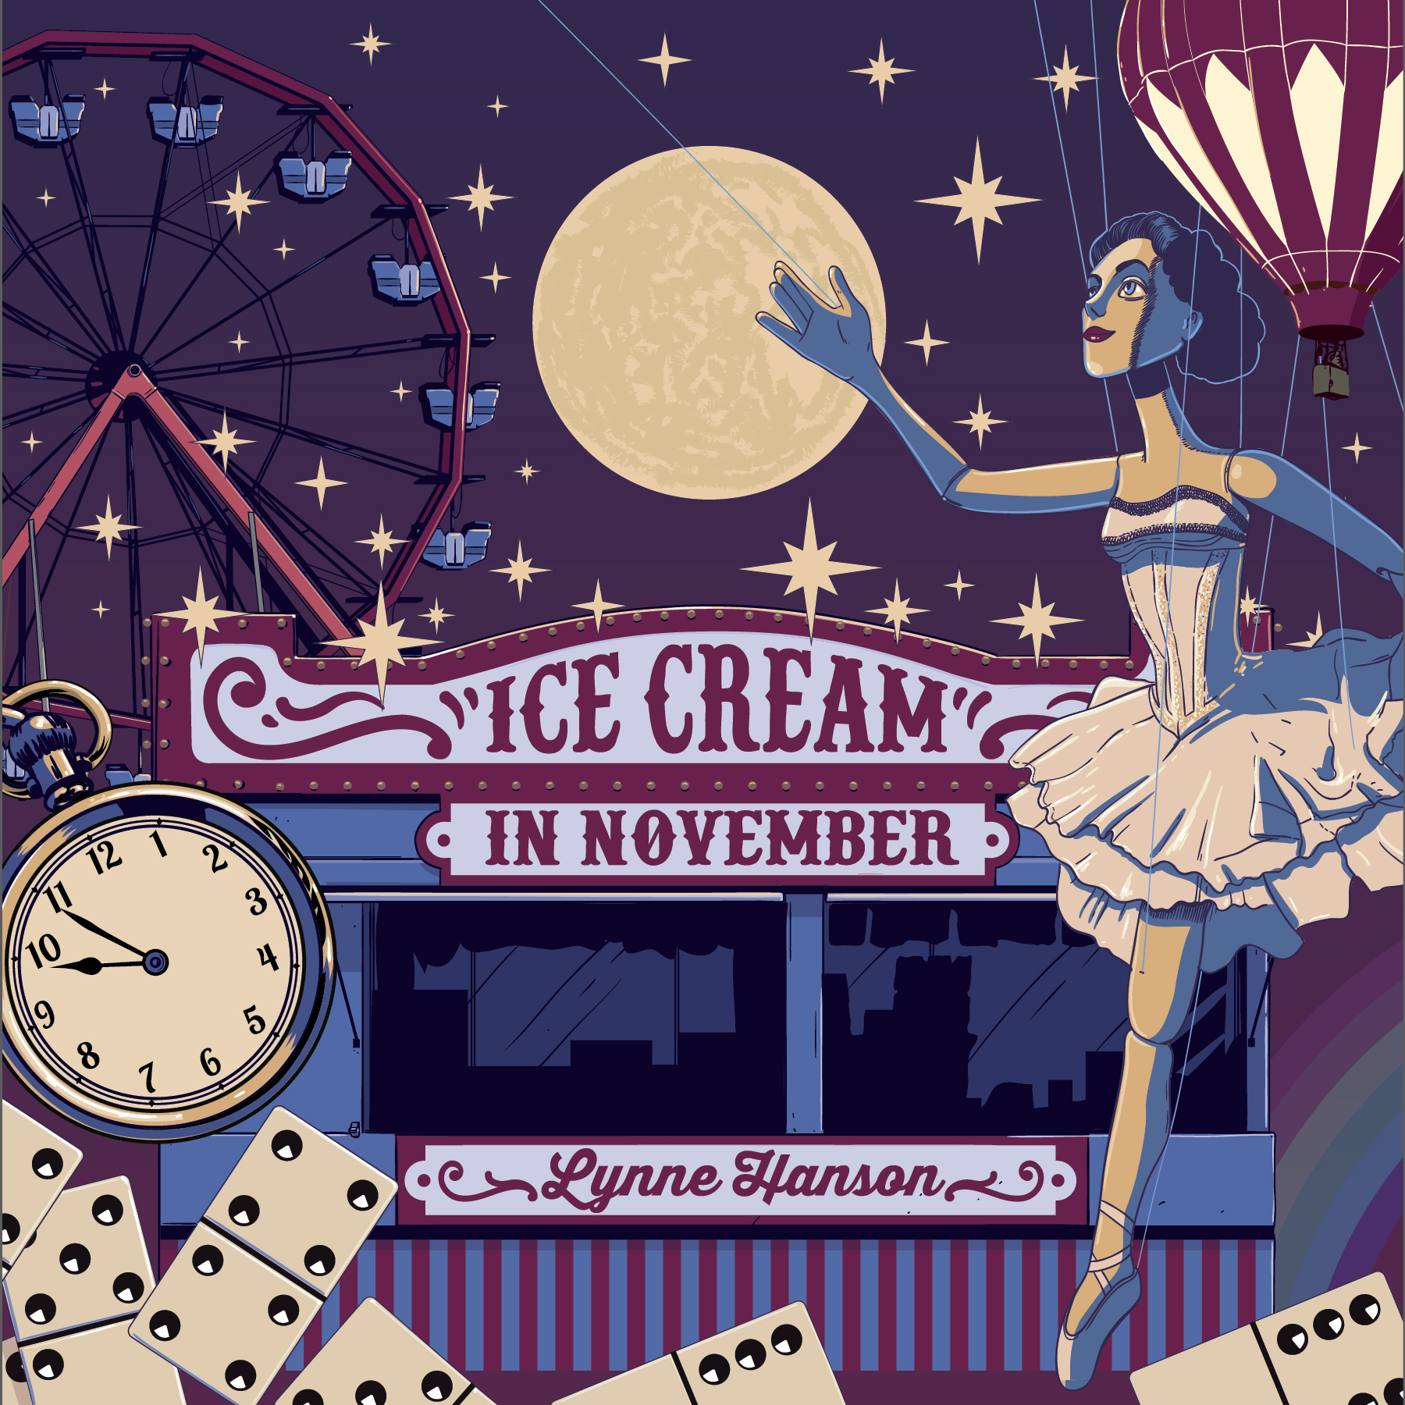
Lynne Hanson
ICE CREAM IN NOVEMBER
RELEASE DATE: APRIL 22, 2022
www.lynnehanson.com
Produced by: Lynne Hanson & Blair Michael Hogan
Panda Cave Records
Evolution isn’t always easy. And change, especially big change, can be scary. Yet this is exactly what Ottawa-based singer-songwriter Lynne Hanson has embraced with her latest effort, Ice Cream in November. Co-produced by Hanson and multi-instrumentalist Blair Michael Hogan, and mixed and mastered by Grammy-nominated sound engineer Phil Shaw Bova, the album was recorded by Hanson and Hogan in their home studios over a two-month period in late summer 2021.
While not abandoning her Americana roots, Ice Cream in November - set for release on April 22, 2022 on Hanson’s label Panda Cave Records - continues the sonic evolution that permeated her 2020 release, Just Words. “I don’t want to keep making the same record over and over again,” Hanson says. “Getting outside of my artistic comfort zone and trying new things is what keeps things fresh for me at this point in my career.” The result is a more contemporary sound that incorporates synthesizers, ethereal guitar pads, and even the odd electronic drum track.
The songs on Ice Cream in November cover a broad range of genres. “In on a Wing” and “One of Those Days” have an indie-rock feel to them, with tongue-in-cheek lyrics that are unpredictably clever. In the fresh-but-retro sounding “Hip Like Cohen,” Hanson sings, “Sipping sidecars while posing / Lining up to be seen / Proud to be post-modern / Without really knowing what that means.” Longtime fans will be happy to know the Hanson trademark red dirt is alive and well on tracks like “Hundred Mile Wind” and “Birds Without a Feather,” while a nod to The Shadows is reflected in the surfy, Hank Marvin-esque guitar and spaghetti western vibe of “Shadowland.” Listeners may find themselves hypnotized by the dreamy hooks of Ice Cream in November, or lost in thought at the questions posed in “Orion’s Belt”: “Like why do songbirds like to sing / Why quicksand isn’t quick at all / And space and time is a relative thing.” And while Hanson still touches on heartache, songs like “Dominoes” and “This Heart of Mine” have a lot more swagger than sorrow to them.
Nine of the 12 songs on the album are co-writes with Hogan, who had only just started touring with Hanson in February 2020. The writing collaboration started when Hanson offered to add a vocal melody and lyrics to an instrumental piece Hogan had posted on social media. This song would eventually become the title track to the new album. “It was an entirely new process for me to have to not only co-write remotely, but to develop lyrics and a vocal melody to a song structure that already existed,” says Hanson. “And in some cases, I was working with chord progressions that may not have been what I would have chosen. It was challenging and liberating at the same time, and it really got me out of the writing funk I was in.”
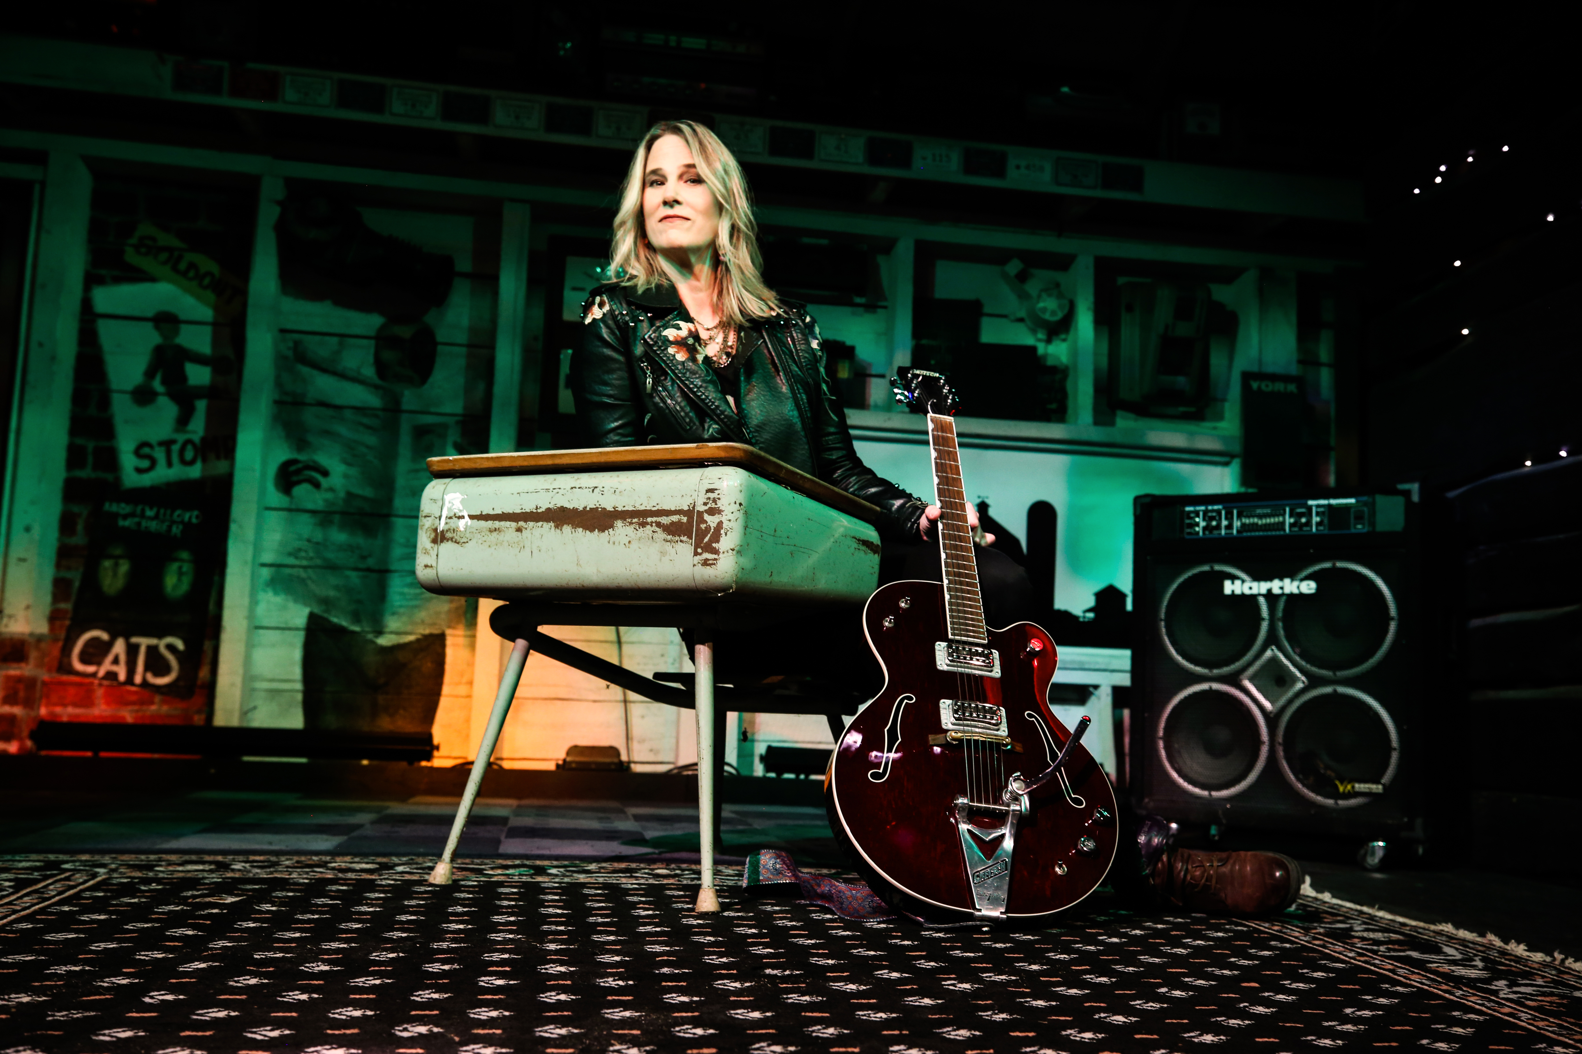
Hanson is no stranger to recording. Since 2006, she’s released eight studio albums - including Heartbreak Song for the Radio, which she co-produced as one half of The LYNNeS. But there’s a big difference between being in the studio and actually being responsible for capturing audio. “The idea of self-engineering my own album was terrifying,” Hanson says. “Prior to 2020, I had never even owned a single piece of recording equipment. So having a talent like Phil ready to mix and master the album gave me the confidence that we could actually do this ourselves.”
photo credit: Emily Rogers
Hanson felt that her recording experience, paired with Hogan’s versatility as a musician, meant they could track the majority of the album themselves. The drums were another story, however. “We knew we wanted real drums on the album, and that was definitely above my pay grade to record properly, so we were really excited when Phil Shaw Bova also agreed to lay down the drum tracks,” Hanson says. “Phil is in very high demand these days and is pretty much exclusively a mastering engineer, but he recorded and played drums on two previous albums and was open to the idea of being more heavily involved in this project.” They also enlisted the help of a few other musician friends, including Peter Klaassen on upright bass, Steve Marriner on harmonica, and Raphael Weinroth-Browne on cello.
Not having the pressure of being on the clock in a commercial studio where time is money, Hanson had the freedom to experiment with arrangements, sounds, and instrumentation on every track. But there was also a downside to having no time limit. “With a home studio, it’s possible to endlessly tinker with a song. At one point, I had to really hunker down and set to say that I’m really proud of what we’ve accomplished with this album, both in terms of the
(continued)
songs themselves, as well as the quality of the production.”
Ultimately, Hanson has created an album of sounds and songs that tied together by well-crafted lyrics and her trademark whiskey-soaked alto, rather than a specific label that you can slot her in. One thing’s for sure, there’s nothing vanilla about Ice Cream in November.

For more information, please contact:
Lynne Hanson / plhanson@gmail.com / +1-613-878-0177

